Quincy Bock

MFADT: Major Studio 2

Final Project Paper

5/7/13

1. Introduction

Science education is not just an issue of the classroom but of society. Our current society and economy are in great need of scientists, engineers, technologies, computer programmers and mathematicians to help lead the way through ever changing global markets and problems. However, our society and education systems are failing to foster the growth of new generations into these roles. Many young people who once were excited by exploration and experimentation are, as they age, losing interest in the sciences because they think they are too hard, boring, not applicable to their lives, or nerdy. The result is a nation falling farther and farther behind in its ability to inspire and educate students in the sciences.[1] Science needs a makeover. Rather than force-feeding facts and figures to reluctant teens or imposing ever-stricter measures of standardization on schools, we need to find more ways to enliven science, ignite a spark of interest and engage not just students in a celebration of science. This can be done through applying contextualized ideas of systems thinking, good design and technologically enabled storytelling.

1. Background

*a. Context and Purpose of Learning*

Two key factors are missing in the presentation of scientific material: application and contextualization. As Sir Ken Robinson argues, the current educational system was designed to create productive contributors to society for a different time.[2] The intellect-loving atmosphere of the Enlightenment created a system for educating children to be successful in the age of the Industrial Revolution. We are no longer in the Industrial Revolution and students do not see the application of science education to their own lives or futures. It is not that this information has no bearing on them anymore, but that it is not presented in a way that seems personally exciting. For example, in a poll of 4,000 students between nine and fourteen years old, nearly half of the children “did not know that they would need a science background in order to pursue a career in plastic surgery.”[3] Something is clearly missing from the process of learning which could greatly contribute to an interest in and motivation to study science.

*a. Gamification*

Science has a reputation for being boring and hard. It exists isolated in textbooks and lonely labs and is divorced from the visually stunning world of HD TVs and fancy cars that it enables. There are excellent exceptions to this rule including fireworks, dissection and explosive chemical reactions; however, scientific material is often framed in a way that is visually uninspiring and de-contextualized.

Conversely, games have an excellent way of presenting information, teaching skills and showing system relationships in dazzling and engaging ways. They do so through design and scaffolding. Games present you with information, challenges, puzzles or tools to help you progress at each stage and contextualize the information in relation to the goal of the game.[4] While gamification is one approach to education, I am not suggesting that science classrooms be completely revamped to become video games. Instead, I think that we can learn from the successes of games and recognize their place in the classroom. As Katie Salen points out, games, playful activities or interactives do not have “to be the holder of all content.”[5] Instead, digital media, interactives or games can deliver just one part of the information of an entire curriculum whether that be the inspiration to learn more, a visualization of systemic relationships or a place to practice one skill.

To apply game theory to science material we can learn from some of the things games do very well:

1. Games make information and tasks personal, embodying the player in the game and showing the systematic relationship between a player’s action and their final goal.
2. Games are visually pleasing making it easy and enjoyable to sift through information.
3. Games contextualize information and tasks by relating the information, player and larger goals in clear, non-abstract ways.

In my project, I will try and apply these three ideas to stimulate excitement about science through contextualization, systemic relationships, and spectacular ideas and visuals.

*a. Precedents*

A good example of this type of supplemental scientific material is the program Swimbots.[6] Swimbots does not teach an individual fact but it exposes users to the systemic relationships of genetics, traits, natural selection and evolution in an illustrative, exploratory and interactive way. By creating a few simple rules and some randomly generated variation, Swimbots beautifully plays out natural selection on a small scale. This program lets users see and experience the process of natural selection through the Swimbots and the “mini-dramas” that the program highlights. By relating the avatars to the user, using phrases like “follow the oldest virgin,” Swimbots contextualizes the ideas of natural selection in a visually pleasing and dramatic way; it also allows users to experience directly, through simulation, the systemic relationships between genes, traits and survival.

To this end, I began researching how I could create my own type of playful and inspiring science material using digital media and interaction.

1. Research

I started my research process by surveying elementary, middle and high school science teachers across the country. I asked teachers a number of questions focused on the process of learning scientific material and the excitement, or lack thereof, that surrounded the subject matter: “What topic do you find hardest to teach? What topic do your students find hardest to grasp? What topic are you most excited to teach? [and] What topic do your students get most excited to learn about?”

I learned that teachers and students both struggled with abstract or intangible ideas. They were both excited about physical or exciting demonstrations and subjects that they could relate easily to themselves and their own lives. This realization helped me narrow the focus of my own project to address an abstract subject matter that does not lend itself easily to physical demonstration or manifestation.

1. Process

To develop my idea, I created a number of prototypes to test different aspects of the final design and weigh them against audience and user reactions. The prototypes included an aesthetic/look and feel prototype, an interaction/participation prototype and an implementation prototype.

*a. Look and Feel*

The first of these was a look and feel prototype. After researching existing scientific demonstrations, materials and simulations, I found that the major downfall of the best scientific simulations or interactions was that the aesthetic choices were arbitrary.[7] In an effort to demonstrate the scientific principles they selected their visuals based on semantic meanings but neglected to consider the narrative of what they are trying to show.

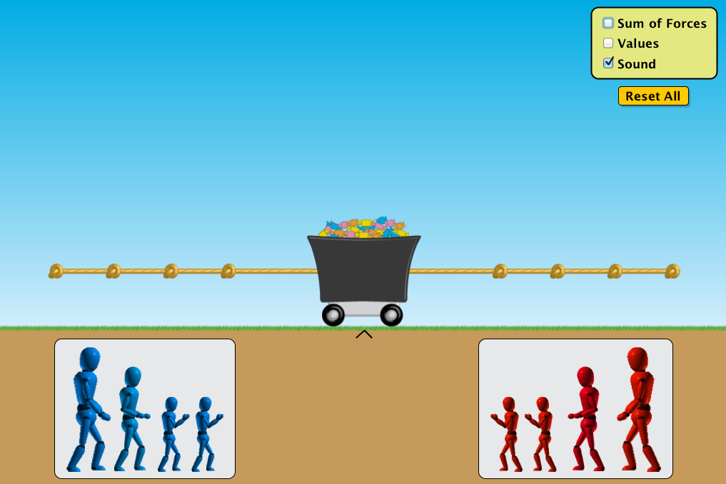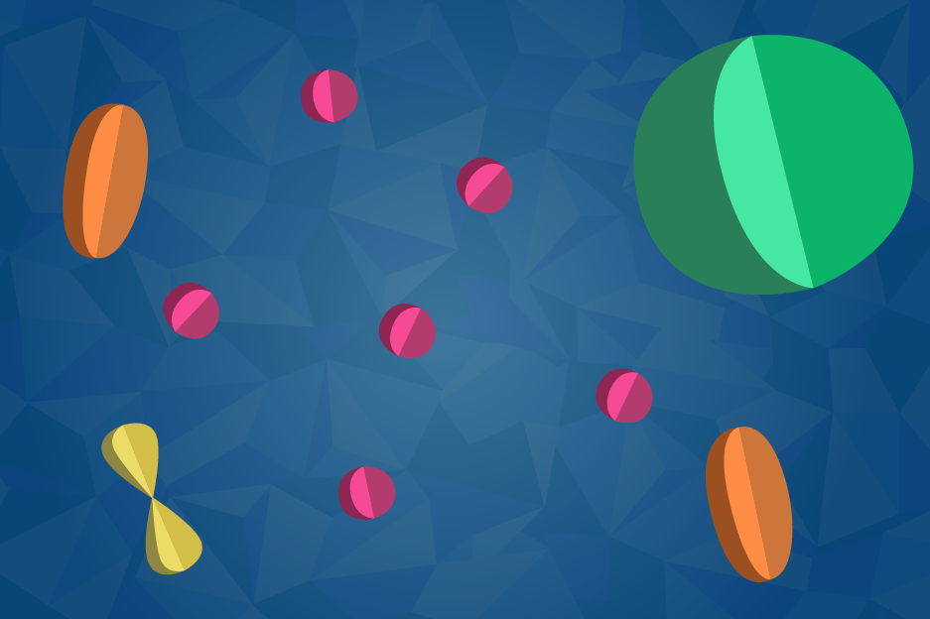

For my own look and feel prototype I created a color pallet and initial mock up of a potential style. I choose bright, saturated colors and a “cutout” style to imply three dimensionality while acknowledging the imprecise nature of representation. While these objects would only ever manifest on the screen I wanted to involve a little bit of physicality by playing with light and shadow. This initial design is by no means the final solution it helped me articulate and explore the ways in which I could consistently apply a design strategy to create a cohesive look and feel.

*b. Interaction*

Middle school is typically the age at which students begin to lose interest in science and mathematics.[8] This is for a number of reasons. Many students think it is too hard or boring, but these ideas usually stem from the fact that they no longer see the relevance of these subjects to their own life or lose sight of the excitement and wonder in science.[9] We need to find ways to reinvigorate interest, involvement and investment in these subjects. To do so I chose to target the abstract ideas from middle school science curriculum that teachers and students struggle with. Atoms, microbiology and anatomy are all within middle school curriculum nationally; however, the relationships between these subjects and their relevance to our lives are not always emphasized. In creating a tool, I did not simply want to teach the terms and facts, but instead focus on the systems relationships and how disciplines interrelate and apply to our lives. In pursuit of this goal, I decided to make an online scrolling animation interaction which demonstrates the hierarchical and systemic relationship between the building blocks of life: atoms, molecules, cells, tissues and organs.

For this prototype I created a storyboard showing how animations would move from atomic to molecular to cellular level creating tissues and organs and then organisms (humans) (http://54.235.78.70/microbio/storyboard/1/#start).

What was successful in this prototype and what I decided to carry forward was a focus on visualization of relationships between scientific subjects (ie between atom and molecule) through animation. What was missing was contextualization of the information and a clear sense of relating each piece back to the individual.

*d. Interaction 2*

For my second interaction prototype I developed a more condensed storyboard and animated part of it so that a user could combine the experience of the narrative with the scrolling mechanic (<http://54.235.78.70/microbio/implementation/4/>). Test users really enjoyed seeing the scrolling mechanic and playing with animating the items on the screen. Although there was not yet any interactivity (other than scrolling), they were able to see the additive demonstration of the hierarchal relationship between the building blocks of life. There were also “sidebars” in the animation to relate each piece back to the user which people were surprised and interested by.

What was successful in this prototype and what I decided to carry forward was the visually pleasing and exciting way of scrolling through the animations and the contextualization of information which related back to the individual. What was missing was a systemic approach at each scale. For the next iteration, I decided to add more systems oriented approach to designing the interface.

1. Project

This project approaches three challenges facing science educators and attempts to solve them through design:

1. Students lose interest in science because they do not see its relevence to their lives.
2. Abstract ideas are difficult to approach and therefore hard to grasp.
3. Systems thinking is missing from divided scientific disciplines.

The design strategies that I am implementing in response to these problems are:

1. Provide supplementary, optional, exploratory information that relates concepts back to the individual in terms of scale, effect, relationships or assembly.
2. Digitally visualize very small and show the scalar relationships between them.
3. Structure the interface such that the interaction with the material is a system. Allow the user to understand the systematic relationships of agents through embodiment. Support non-linear, multi-dimensional experiences.

To synthesize these ideas into one interface and apply them to middle school curriculum, I have developed a multiuser web interaction which leads users through physical systems at different scales to experience the assembly of matter into life.

Users begin on a screen displaying the scales which can explored: subatomic particles, atoms, molecules, polymers, cells, tissues and organs. Each of the levels except subatomic particles is locked because in order to assemble atoms you must first have subatomic particles, to make molecules you must first have atoms, etc. When users click on each level they are presented with three sequential screens: a contextualization screen, a system’s-agent screen and a goal screen. After these screens are passed they move on to a participatory, collaborative and systems thinking based interaction. I will describe the subatomic level as an example to explain what each screen and interaction does.

The contextualization screen for the subatomic particles shows the individual parts of an atom (proton, electron, neutron, charges, etc) with one sentence summaries of the function of each part and its relationship to the system. Around the diagram and text there are pulsing spots indicating “contextualization” information which can be clicked on to reveal more content. This content is focused on showing how the part relates back to the individual user, why it is interesting or important, analogies for understanding scale or hypotheticals to promote thought and inquiry. An example would be a spot located between the nucleus and electron. When clicked it would have an illustration and tell the user in text, “The distance between the nucleus of an atom and the electrons is (relatively speaking) incredibly big. If there were no space between atoms, everyone who has ever lived on earth would fit inside a baseball. What do you think it would be like if this space were smaller?”

In the system’s-agent screen users would see each of the elements they learned about in the contextualization screen separated. User select which one they wanted to “be” for the interactive portion. For subatomic particles, users are able to select from any of the system inputs from particles to forces, etc. (electron, proton, fusion reaction, charge force). Items “sell out” so as to insure that one of each item is represented in the interactive portion.

The goal screen would show the users some of the outputs or resulting systems of this level and allow them to select which items they want to build in the interactive portion. For subatomic particles, users would be offered an array of elements (the whole periodic table) from which they could select a subset to “build.”

In the interactive screen, users have to work together acting as inputs and agents in the system to create outputs, build larger systems and exchange energy and information. In the subatomic level, users have to work together by moving their mouse around the screen and clicking in conjunction with other users to build elements. For example, to build a Helium atom two protons (and one or two neutrons) would have to be fused with a fusion reaction and then electrons would have to be bound to the nucleus with the electric force. This would involve the cooperation of at least four people demonstrating the complexity of the system and the different agents roles and interactions in the system.

Through the metaphor of assembly, users would progress through the different levels of scale, complexity and systems exploring the inputs, outputs, agents and interactions at each level. By visualizing these scientific ideas digitally and making them tangible and interactive, I hope to combat the problem of abstraction. By embedding information that contextualizes scientific facts and principles, I hope to relate science to the student and show its relevance and application to their lives. And by entrench this information in a collaborative, multiuser interface, I hope to convey the ideas of systems thinking through the interaction with the subject matter and other users.

1. Conclusion

This project attempts to create a tool to make science education more engaging and effective by employing ideas of systems thinking in design and education and by contextualizing information to prove its relevance. Because students are losing interesting in science we need to create new design strategies not only to convey information but to invigorate interest in science. While students seem to be increasingly drawn away from education by technology, we now have powerful digital tools to deliver content widely and in participatory, exploratory and interactive ways. We can use these tools to tell a story about science and teach through the interfaces themselves.

1. References

“Children losing interest in science through their education, report claims.” The Telegraph. 7 Sep 2008 <http://www.telegraph.co.uk/news/uknews/2700145/Children-losing-interest-in-science-through-their-education-report-claims.html>.

“General Systems Theroy,” Bertalanffy Center for the Study of Systems Science. <http://www.bertalanffy.org/system-theory/general-system-theory/>.

Podolefsky, Noah. “Forces and Motion: Basics.” PhET Colorado. 23 Oct 2012 <http://phet.colorado.edu/en/simulation/forces-and-motion-basics>.

Rich, Motoko. “U.S. Students Still Lag Globally in Math and Science, Tests Show.” The New York Times, 12 Dec 2012 <http://www.nytimes.com/2012/12/11/education/us-students-still-lag-globally-in-math-and-science-tests-show.html?_r=0>.

Robinson, Sir Ken. “Changing Education Paradigms.” theRSAorg. 14 Oct 2010 <http://www.youtube.com/watch?v=zDZFcDGpL4U&feature=player_embedded>.

Salen, Katie. “Big Thinkers: Katie Salen on Learning with Games.” Edutopia. 27 Mar 2009 <http://www.edutopia.org/digital-generation-katie-salen-video>.

“Seventh Grade Science Standards.” Internet for Classrooms. 2010 <http://www.internet4classrooms.com/skills_7th_science_new.htm>.

Sweeney, Linda Booth and Dennis Meadows. The Systems Thinking Playbook. Chelsea Green Publishing, 1995.

Ventrella, Jeffrey. “GenePool Wiggly Evolution,” 2010 <http://www.swimbots.com/>.

1. Motoko Rich, “U.S. Students Still Lag Globally in Math and Science, Tests Show,” The New York Times, 12 Dec 2012 <http://www.nytimes.com/2012/12/11/education/us-students-still-lag-globally-in-math-and-science-tests-show.html?_r=0>.
2. Sir Ken Robinson, “Changing Education Paradigms,” theRSAorg, 14 Oct 2010 <http://www.youtube.com/watch?v=zDZFcDGpL4U&feature=player_embedded>.
3. “Children losing interest in science through their education, report claims,” The Telegraph, 7 Sep 2008 <http://www.telegraph.co.uk/news/uknews/2700145/Children-losing-interest-in-science-through-their-education-report-claims.html>.
4. Katie Salen, “Big Thinkers: Katie Salen on Learning with Games,” Edutopia, 27 Mar 2009 <http://www.edutopia.org/digital-generation-katie-salen-video>.
5. Salen.
6. Jeffrey Ventrella, “GenePool Wiggly Evolution” 2010 <http://www.swimbots.com/>.
7. Noah Podolefsky, “Forces and Motion: Basics,” PhET Colorado, 23 Oct 2012 <http://phet.colorado.edu/en/simulation/forces-and-motion-basics>.
8. The Telegraph.
9. The Telegraph.